1-Network and Computer Network

1-Network

🌐 What Is a Network (In General)?
# Source: AI Source: Provided by: [Data Path: Persons Table -> ID Column: 1, Name_En Column: Motasem Essam] -> From: [ChatGPT] on [12/9/2025]
A network—in general—is a system of interconnected components that can communicate, share resources, or exchange information with each other.

🧠 In simple terms:
# Source: AI Source: Provided by: [Data Path: Persons Table -> ID Column: 1, Name_En Column: Motasem Essam] -> From: [ChatGPT] on [12/9/2025]
A network is a group of things connected together.

🔗 General Examples of Networks
# Source: AI Source: Provided by: [Data Path: Persons Table -> ID Column: 1, Name_En Column: Motasem Essam] -> From: [ChatGPT] on [12/9/2025]
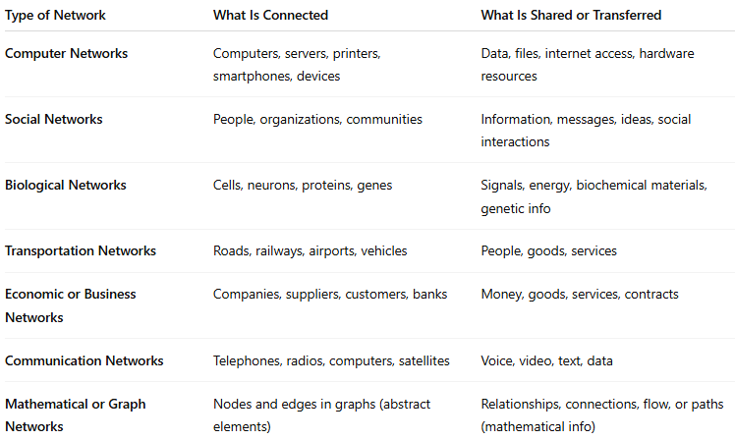
Type of Network | What Is Connected | What Is Shared or Transferred
Computer Networks | Computers, servers, printers, smartphones, devices | Data, files, internet access, hardware resources
Social Networks | People, organizations, communities | Information, messages, ideas, social interactions
Biological Networks | Cells, neurons, proteins, genes | Signals, energy, biochemical materials, genetic info
Transportation Networks | Roads, railways, airports, vehicles | People, goods, services
Economic or Business Networks | Companies, suppliers, customers, banks | Money, goods, services, contracts
Communication Networks | Telephones, radios, computers, satellites | Voice, video, text, data
Mathematical or Graph Networks | Nodes and edges in graphs (abstract elements) | Relationships, connections, flow, or paths (mathematical info)

